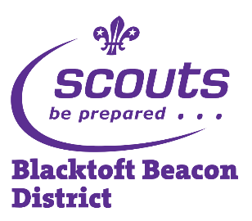
Nights Away Information Form
Blacktoft Beacon District Scouts
Event: | Scout Camp Craft Competition
Dates: | Friday 18th May 2018, 6:30pm to Sunday 20th May 2018, 3:00pm
Location: | Tablers Wood District Campsite, Carr Lane, West Cowick, Goole, DN14 9ED
Meeting place and time: | Please delete and fill in appropriate to your Troop
Collection place and time: | Please delete and fill in appropriate to your Troop
Transport details: | Please delete and fill in appropriate to your Troop
Activities: | As part of the competition the Scouts will rotate around a selection of challenge bases to earn points. As a patrol they will also cook for themselves, pitch and strike their own camp set-up.
Organiser and contact details: | Linda Thelwell, 4 The Forge, Little Weighton HU20 3UJ 07740 553710
Contact details during the event: | Please delete and fill in appropriate to your Troop  PTO

Please keep this section for your own information, and detach and return the section below.

Note: All activities will be run in accordance with The Scout Association’s safety Rules. No responsibility for the personal equipment/clothing and effects can be accepted by the organisers and The Scout Association does not provide automatic insurance cover in respect to such items.

Please complete and return this part to your section Leader by Please delete and fill in appropriate to your Troop

Name of young person: |  |  | D.O.B:
Event: | Scout Camp Craft Competition
I enclose a cheque / cash for £ Fill in. (please makes cheques payable to Fill in appropriate to your Troop)
I have noted the arrangements above and agree to the named young person taking part. I understand that the event Leader reserves the right to send any participants home if deemed necessary.
Emergency contact: |  |  | Phone:
Doctor’s name and contact details: |  | Details of any medications currently being taken:
Details of any disabilities, conditions, allergies, special needs or cultural needs that might affect this event: |  | Details of any infectious diseases he/she has been in contact with in the last three weeks:
I give permission for photographs and/or videos of the named young person to be used for the promotion of Scouting. YES / NO

If it becomes necessary for the above named young person to receive medical treatment and I cannot be contacted to authorise this, I hereby give my general consent to any necessary medical treatment and authorise the Leader in charge to sign any document required by the hospital authorities.
Signed: |  | Date:
Relationship to young person:
Please use the back of this form if more space is required

