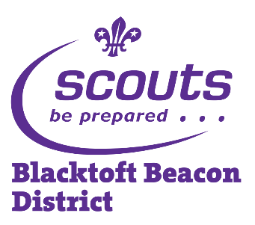
Activity Information Form
Blacktoft Beacon District Scouts
Event: | Cub Camp Craft Competition
Date: | Saturday 19th May 2018 Start: 10:00am Finish: 3:00pm
Location: | Tablers Wood District Campsite, Carr Lane, West Cowick, Goole, DN14 9ED
Meeting place and time: | Please delete and fill in appropriate to your Pack
Collection place and time: | Please delete and fill in appropriate to your Pack
Transport details: | Please delete and fill in appropriate to your Pack
Wear / Bring: | Please wear activity dress & bring waterproofs and a packed lunch in a day bag.
Further details: | The Cubs will rotate around a selection of challenge bases to earn points.
Organiser and contact details: | Linda Thelwell, 4 The Forge, Little Weighton HU20 3UJ 07740 553710
Contact details during the event: | Please delete and fill in appropriate to your Pack
Please keep this section for your own information, and detach and return the section below.
Note: All activities will be run in accordance with The Scout Association’s safety Rules. No responsibility for the personal equipment/clothing and effects can be accepted by the organisers and The Scout Association does not provide automatic insurance cover in respect to such items.

Please complete and return this part to your section Leader by Please delete and fill in appropriate to your Pack

Name of young person: |  |  | D.o.B:
Event: | Cub Camp Craft Competition
I enclose a cheque / cash for £ Fill in. (please makes cheques payable to Fill in appropriate to your Pack)
I have noted the arrangements above and agree to the named young person taking part. I understand that the event leader reserves the right to send any participants home if deemed necessary.
Emergency contact: |  |  | Phone:
Doctor’s name and contact details: |  | Details of any medications currently being taken:
Details of any disabilities, conditions, allergies, special needs or cultural needs that might affect this activity: |  | Details of any infectious diseases he/she has been in contact with in the last three weeks:
I give permission for photographs and/or videos of the named young person to be used for the promotion of Scouting. YES / NO

If it becomes necessary for the above named young person to receive medical treatment and I cannot be contacted to authorise this, I hereby give my general consent to any necessary medical treatment and authorise the Leader in charge to sign any document required by the hospital authorities.
Signed: |  | Date:
Relationship to young person:
Please use the back of this form if more space is required

