District Camp Craft Competition 2017 – Entry Form

Please return this page by Friday 5th May 2017
to depdc@blacktoftbeacon-scouts.org.uk

Section: | Please circle as appropriate.  Cubs Scouts
Team Name:
Number in Team:

Entry fees should be sent once confirmation of your booking has been received and this will secure your team's place.
£5 per Cub Team
£10 per Scout Team
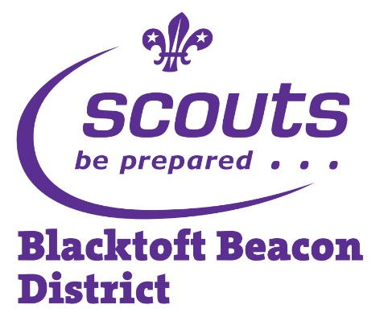
Sections can enter more than one Team, places will be allocated on a first come first served basis.

